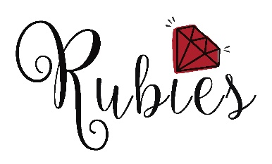
‘Sparkle & Slime’

What? A FREE event for girls aged 10-12, with arts & crafts workshops, a slime lab, lunch and more..!
When? Tuesday 27th August 11am – 2:30pm (registration from 10:45am)
Where? Inspire2Learn Centre, Normanby Road, South Bank TS6 9AE
Who? For girls aged 10-12 - especially those moving to secondary school in September and who’ve worked with Rubies this year
Why? Because we’d love to catch up with everyone, and provide a little confidence boost before term starts!

The important info: Places MUST be booked in advance, no later than Friday 23rd August.
Girls MUST return this completed & signed consent form via email, or bring the paper copy with them on the day. Girls will not be able to attend the event without this.
Rubies cannot be responsible for girls if they leave the Inspire2Learn centre at any point during the event.
Please let us know if your child has any health issues or food allergies as lunch will be provided.

For more details, or to book a place please contact Liz Edwards

Tel 07840 242581
Email: liz@wearerubies.org
Website: www.wearerubies.org
Facebook – Rubies Charity
Twitter – @Rubiescharity Registered charity number 1177332

----------------------------------------------------------------------------------------------------------------------------------------------

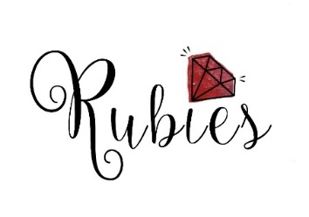
Name of child…………………………………………. D.O.B………………………..

Name of parent / guardian……………………………………………………………..

Address…………………………………………………………………………………..

…………………………………………………………………………………………….

………………………………………... Postcode……………………………………...

Parent / guardian’s phone number……………………………………………………………………………………..

Name /phone number of second emergency contact……………………………………………...........................

Details of health issues/food allergies………………………………………………………………………………...

I give permission for my daughter to attend ‘Sparkle & Slime,’ according to the terms listed above.

I give permission for Rubies to take photographs of my daughter for publicity and promotion purposes.

Signed……………………………………………………. Date………………………………………………………..

